Comments and screenshots

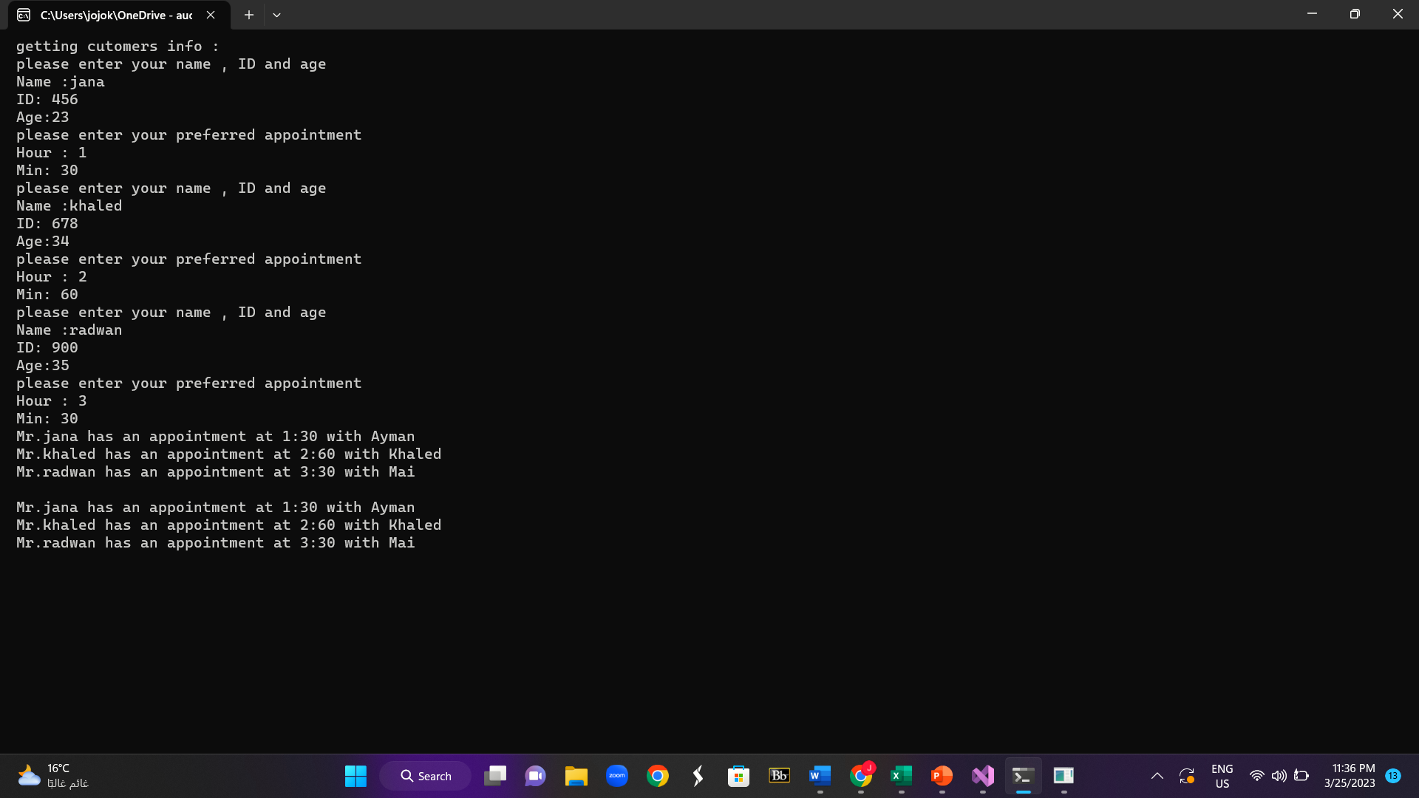

I couldn’t optimize the int main file as it had many nested if statements and I think something is wrong with my laptop storage as it gave me an unknown error